# CRICKET MANAGEMENT SYSTEM



NAME: KAVISH

ID NO. : 2021A7PS0559P

# INTRODUCTION

My DBMS project is based on Cricket database management system. It provides various information about the various teams participating in the World Cup, in which all the major countries participate. It also provides us with information about the various players participating in the tournament. The database contains details of players, coaches, matches, wicket keepers and umpires among others. All the useful information about the entire World Cup can be found here.

# DATA REQUIREMENTS

Entities:

1. Team: is an entity type which has many attributes like Team Name which uses the data type varchar. Every team has been given a Team ID which is the primary key which is of data type varchar. There are another attribute – Coach Name and Home Ground which accepts varchar data type.

Primary key cannot have null value.

1. Players: is an entity type which has an attribute – Player Name which is of the data type varchar. It has a primary key, Player ID, which cannot have null value. It has a foreign key, Team ID which is the primary key of the entity, Team. There is an attribute age of which accepts only integer values and another attribute Playing Type

which is of data type varchar.

1. Scores: is an entity type with a primary key, Score ID of data type INT. It has two foreign keys, i) Player id from table Players and ii) Match ID from table Matches. Runs Scored and Wickets Taken are also attributes of this table of data type INT. Aso have one more attribute Overs Bowled having data type float.
2. Matches: is an entity type with a primary key, Match ID, of INT data type. It has attributes like Team1 ID, Team2 ID, Winner Team ID of data type INT and Location of data type varchar. Match Date is an attribute which uses the data type date.

Relationships:

Cricket player plays in team: a cricket player can play in only one team but a team can have many players in it but a team must have players in it.

Team plays match: Team can play many matches and a match can be played by two teams.

Runs Scored by a player: Multiple players can score in a single match and single player can score in multiple matches.

**ER DIAGRAM:**

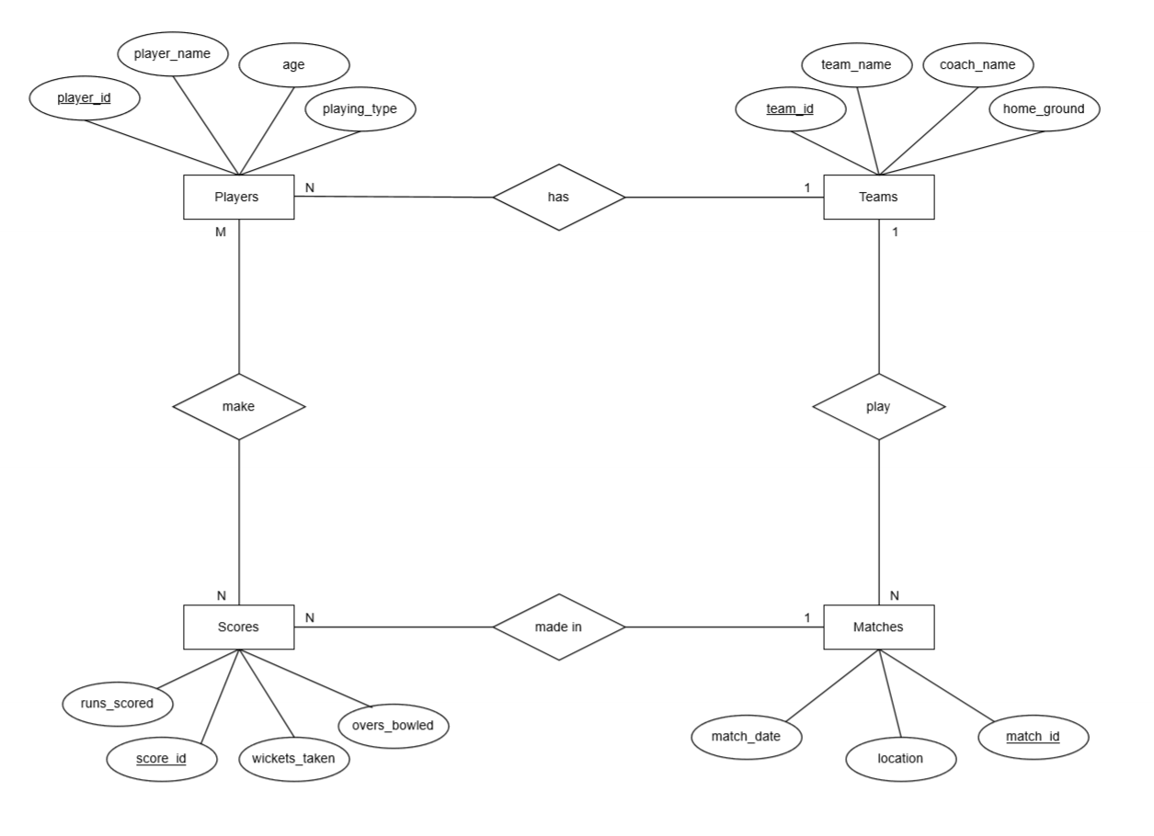

RELATIONAL SCHEMA

* **Team** (team_id, team_name, coach_name, home_ground)
* **Player** (player_id, player_name, age, playing_type, team_id)
* **Match** (match_id, match_date, location, team1_id, team2_id, winner_team_id)
* **Score** (score_id, match_id, player_id, runs_scored, wickets_taken,overs_bowled)

**NOTE:-**

**Candidate Keys Are:**

team_id

player_id

match_id

score_id

**Foreign Keys Are:**

Players.team_id references Teams.team_id

Matches.team1_id references Teams.team_id

Matches.team2_id references Teams.team_id

Matches.winner_team_id references Teams.team_id

Scores.match_id references Matches.match_id

Scores.player_id references Players.player_id

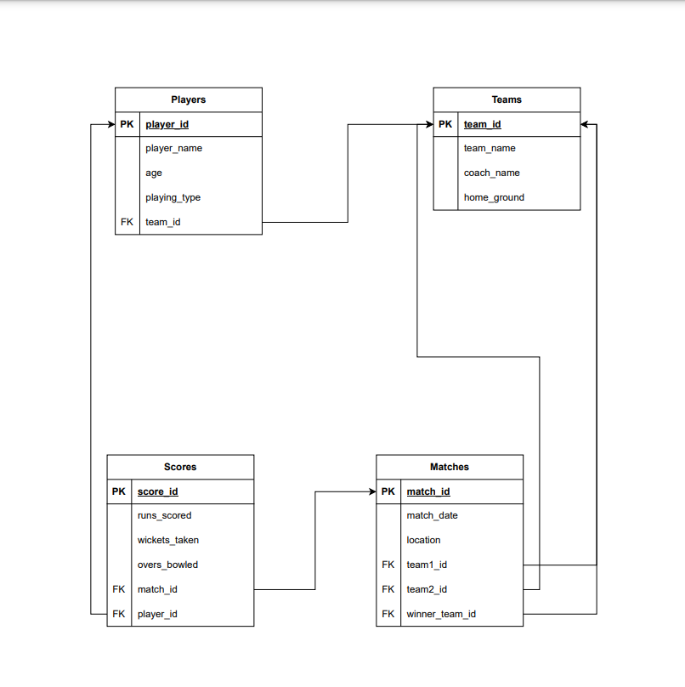

NORMALIZATION

**Functional dependencies for each relation:**

* Functional dependencies for Players:

player_id → player_name, age, playing_type,

team_id

team_id → team_id, team name, coach_name,

home_ground

* Functional dependencies for Matches:

match_id → match_date, location, team1_id

team2_id, winner_team_id

* Functional dependencies for Scores:

score_id → match_id, player_id, runs_scored,

wickets_taken, overs_bowled

NOTE:-

* 1. There are no partial dependencies in any

Of the relations.

* 1. For Players, we have a transitive dependency: team_id → team_name, coach_name, home_ground.

We can remove this by creating a new relation

for Teams with team_id as the primary key and

team_name, coach_name, and home_ground as

attributes.

Teams (team_id, team_name, coach_name,

home_ground)

* 1. For Scores, we have a transitive dependency: match_id → team1_id, team2_id, winner_team_id. We can remove this by creating a new relation for Matches with match_id as the primary key and match_date, location, team1_id, team2_id, and winner_team_id as attributes.

Matches (match_id, match_date, location, team1_id, team2_id, winner_team_id)

**The final normalized relations are:**

* Players (player_id, player_name, age, playing_type, team_id)
* Teams (team_id, team_name, coach_name, home_ground)
* Matches (match_id, match_date, location, team1_id, team2_id, winner_team_id)
* Scores (score_id, match_id, player_id, runs_scored, wickets_taken, overs_bowled)

**ALL RELATONDS ARE NOW IN 3NF, AND THERE ARE NO TRANSITIVE DEPENDENCIES.

# SQL OUERIES AND THEIR OUTPUT SCREENSHOTS

1.Create a table for players with fields such as

player_id, player_name, player_age,

player_position, and team_id.

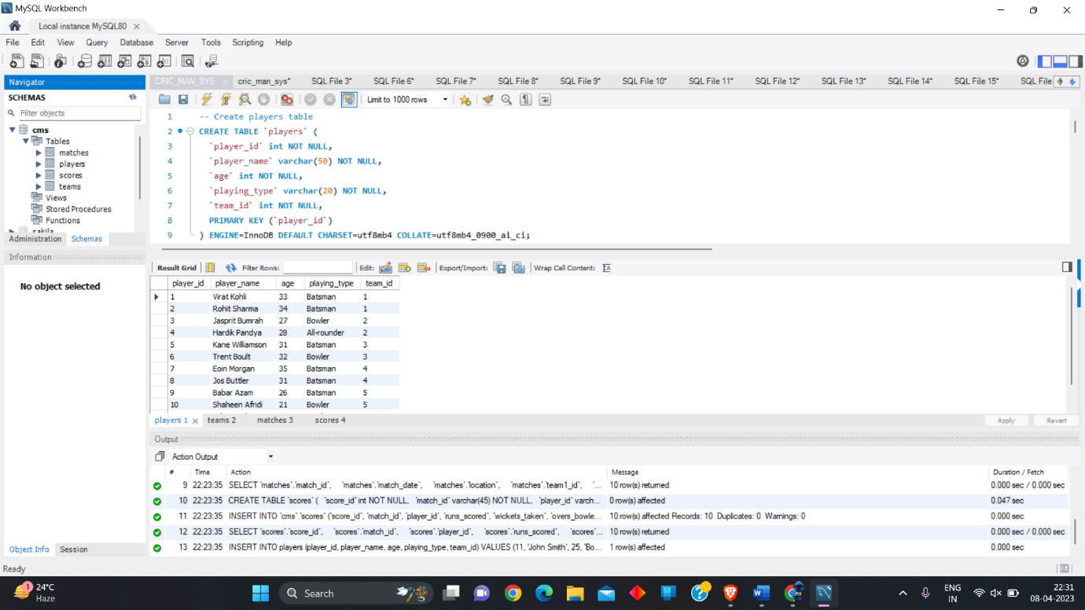

2.Create a table for teams with fields such as

team_id, team_name, coach_name, and

home_ground.

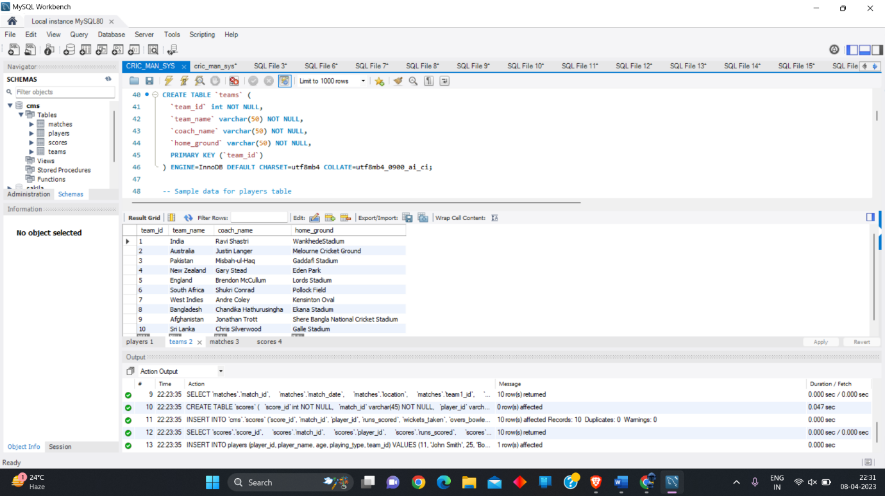

3.Create a table for matches with fields such as

match_id, match_date, location, and

winner_team_id.

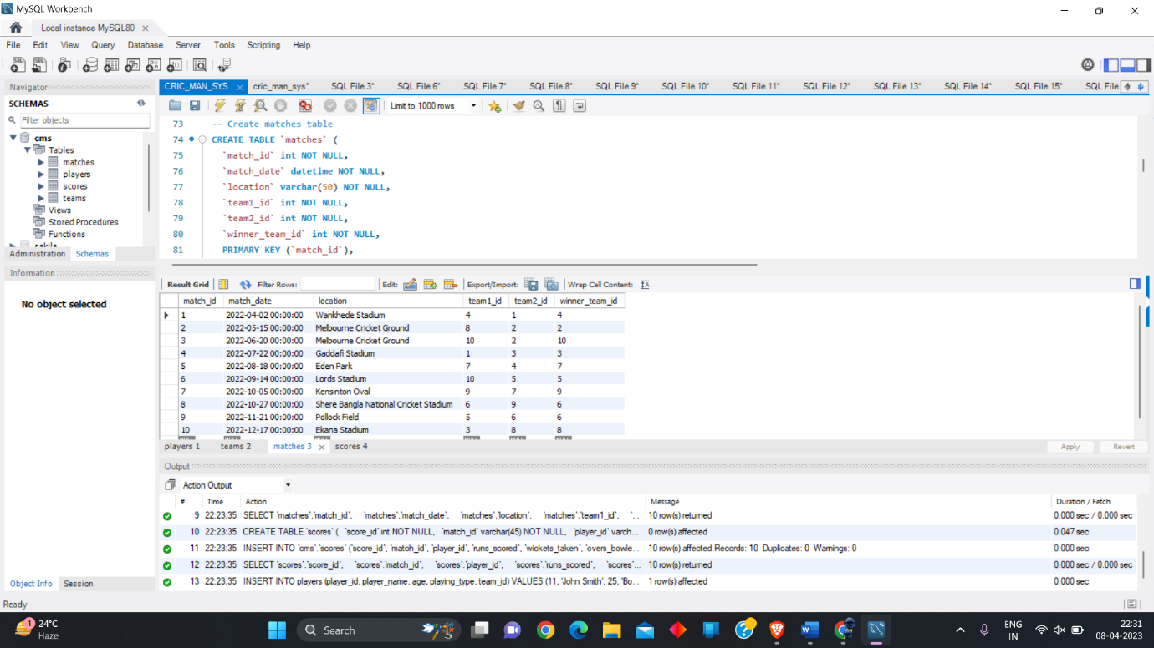

4.Create a table for scores with fields such as

score_id, match_id, player_id, runs_scored,

wickets_taken, and overs_bowled.

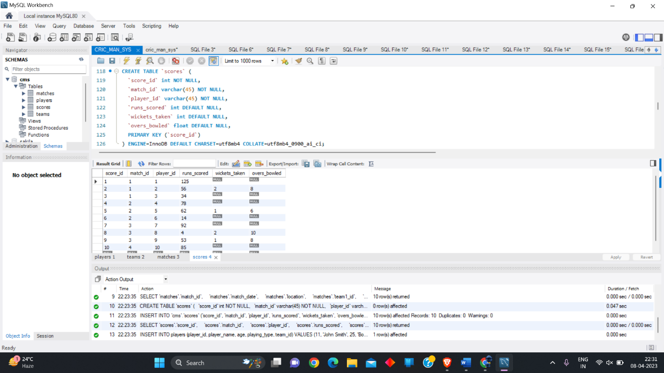

5.Insert a new player record with player_name

“John Smith”, player_age 25, player_type

“bowler”, and team_id 2.

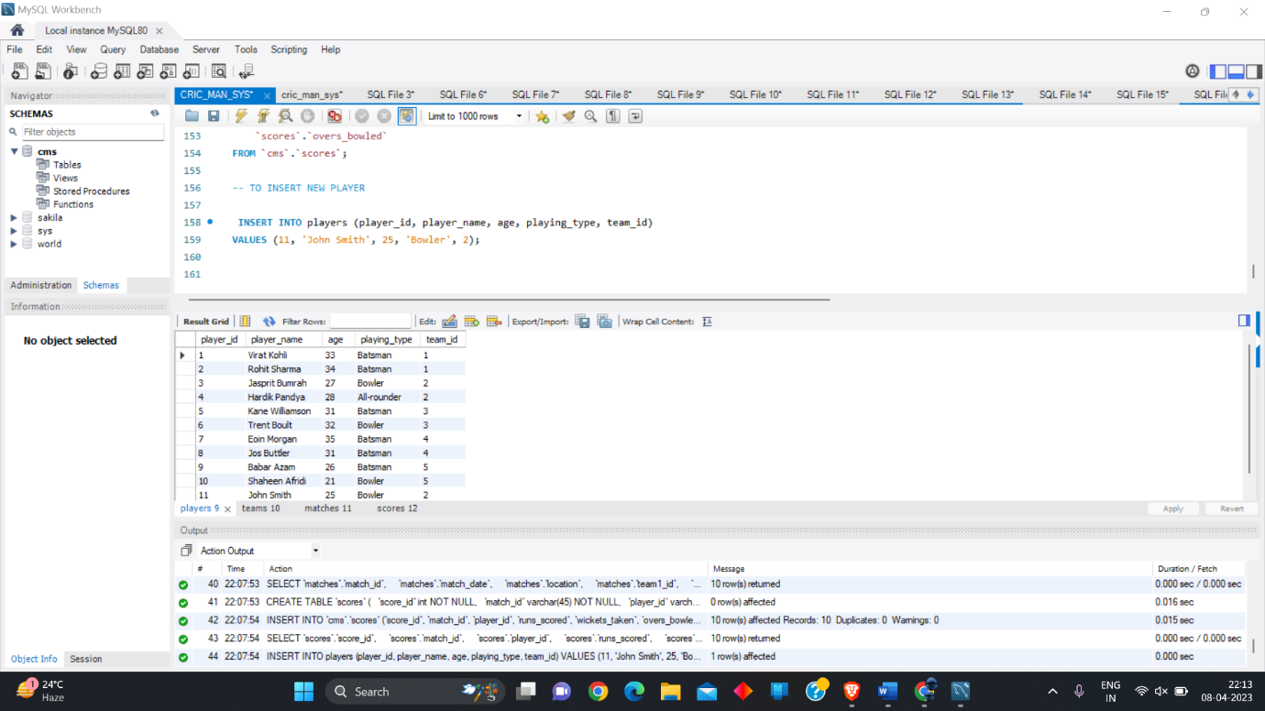

6.Update the coach_name for team_id 1 to “Rahul

Dravid”.

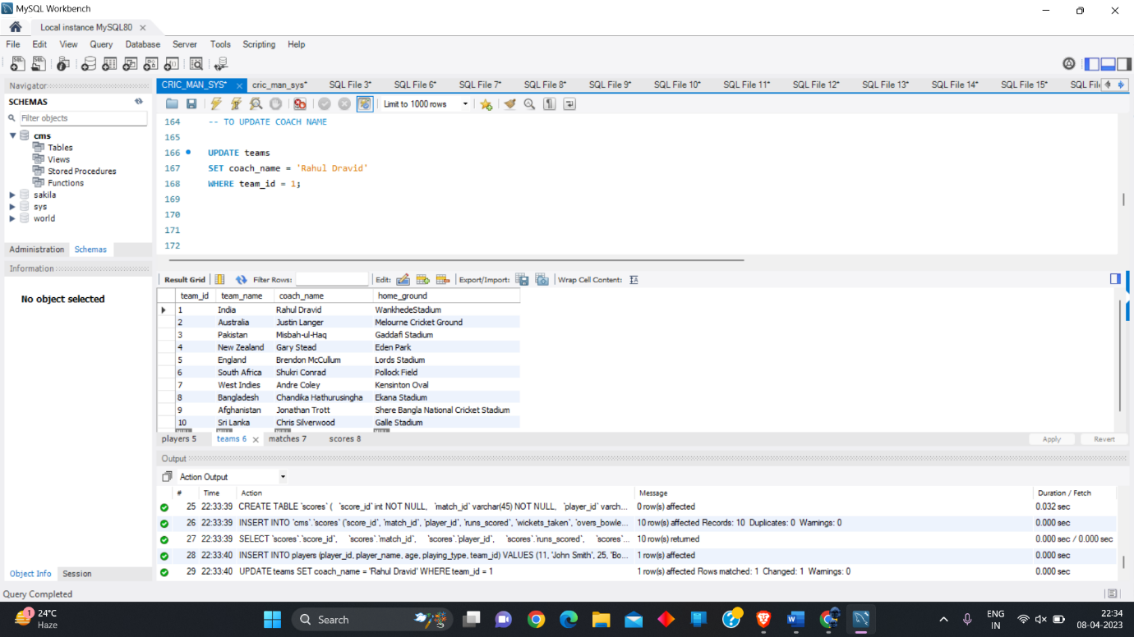

7.Delete all records from the scores table where

runs_scored is less than 50.

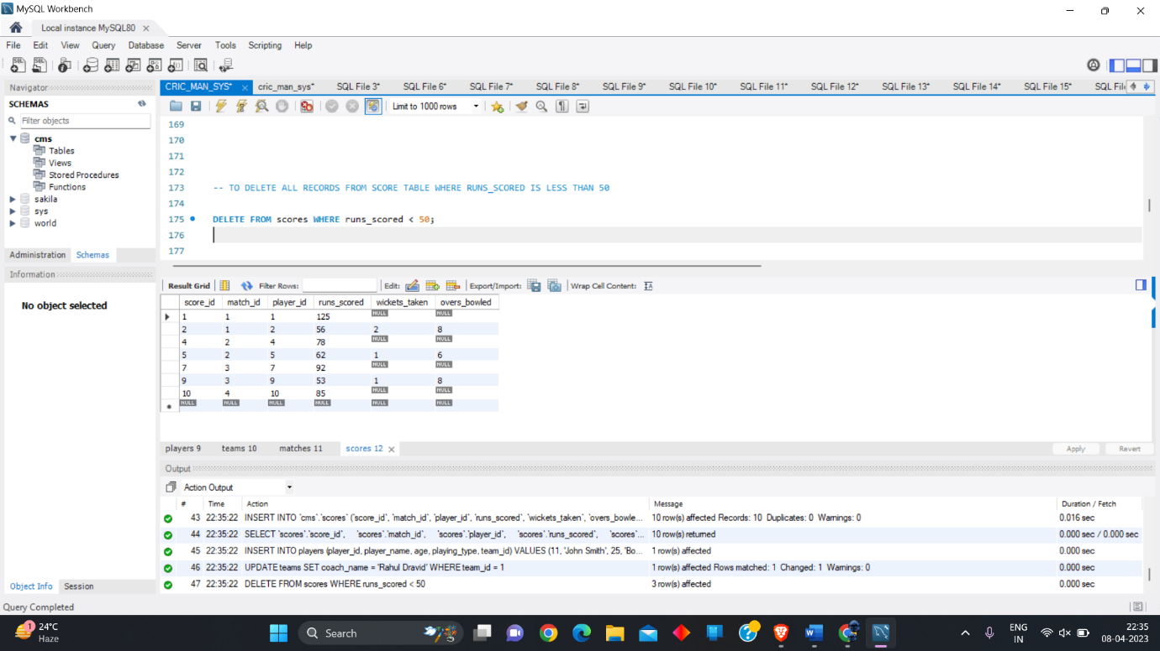

8.Insert a new match record with match_date “2022

03-15", location “Mumbai”, and competing

team_ids 1 and 2.

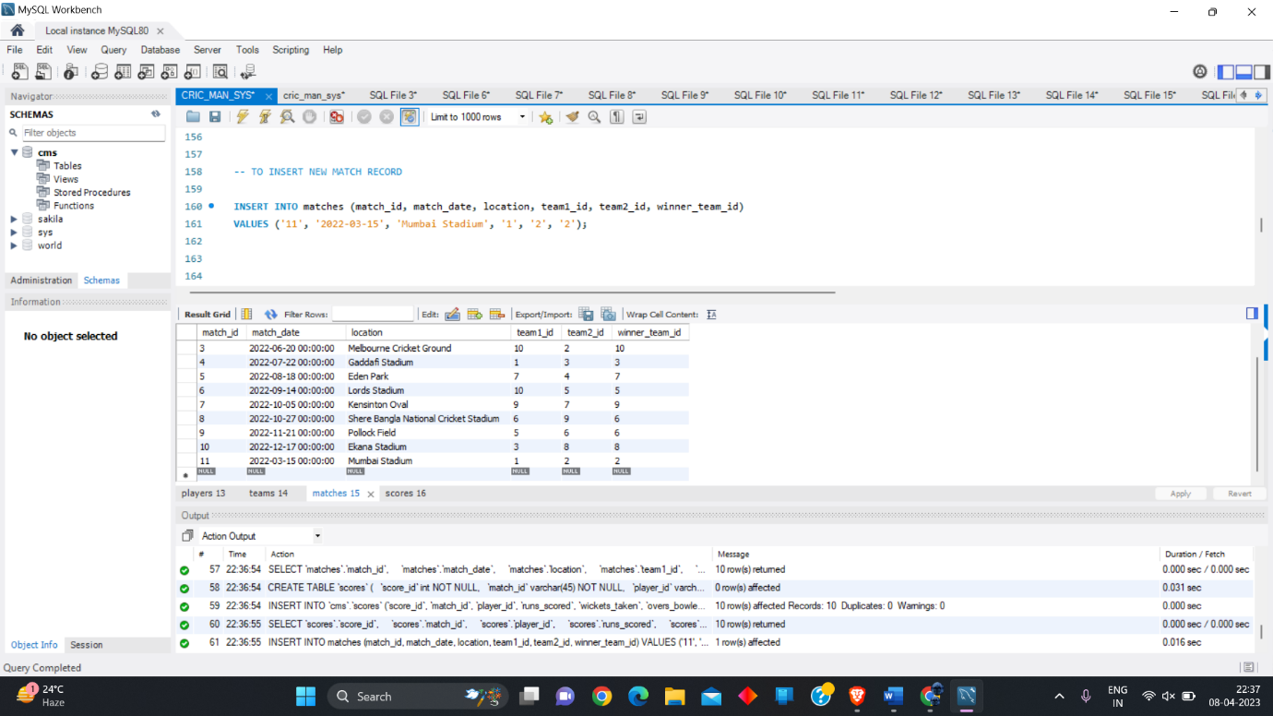

9.Update the winner_team_id for match_id 1 to 1.

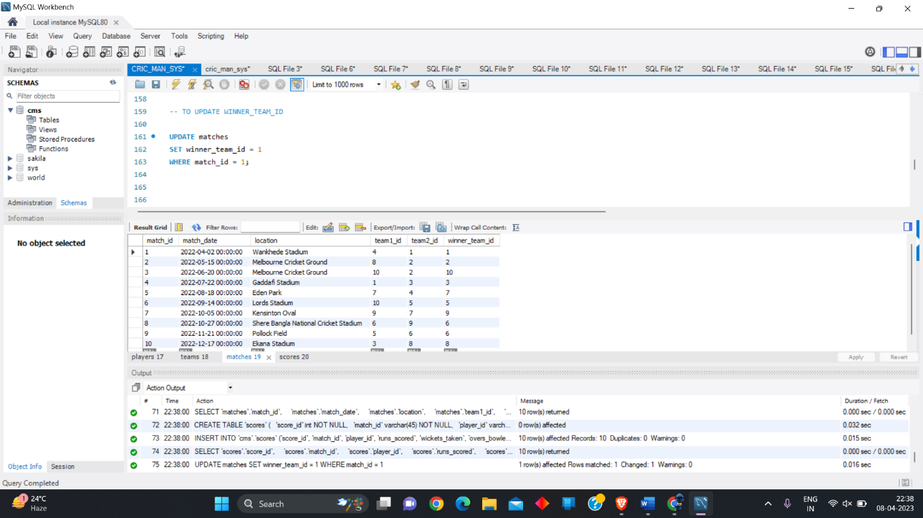

10.Retrieve the highest runs_scored by a player in a

match.

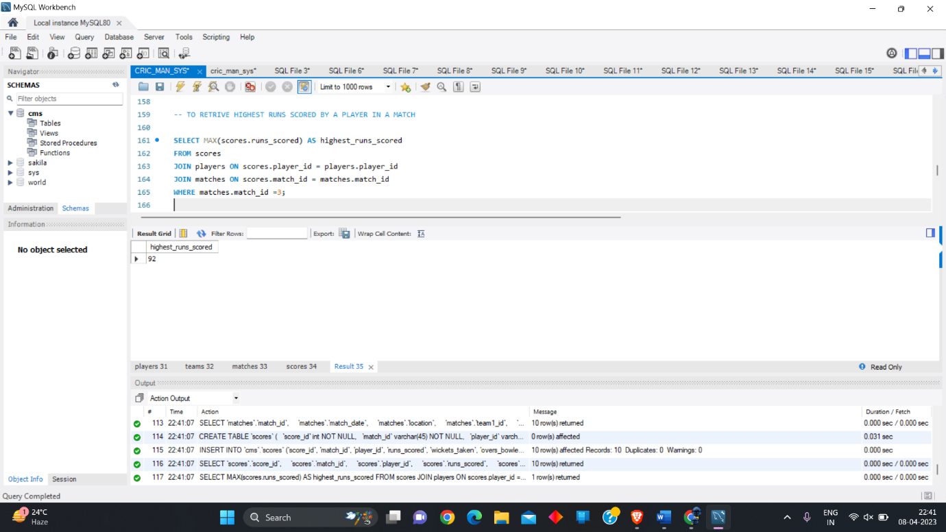

11.Retrieve the total number of matches won by

each team.

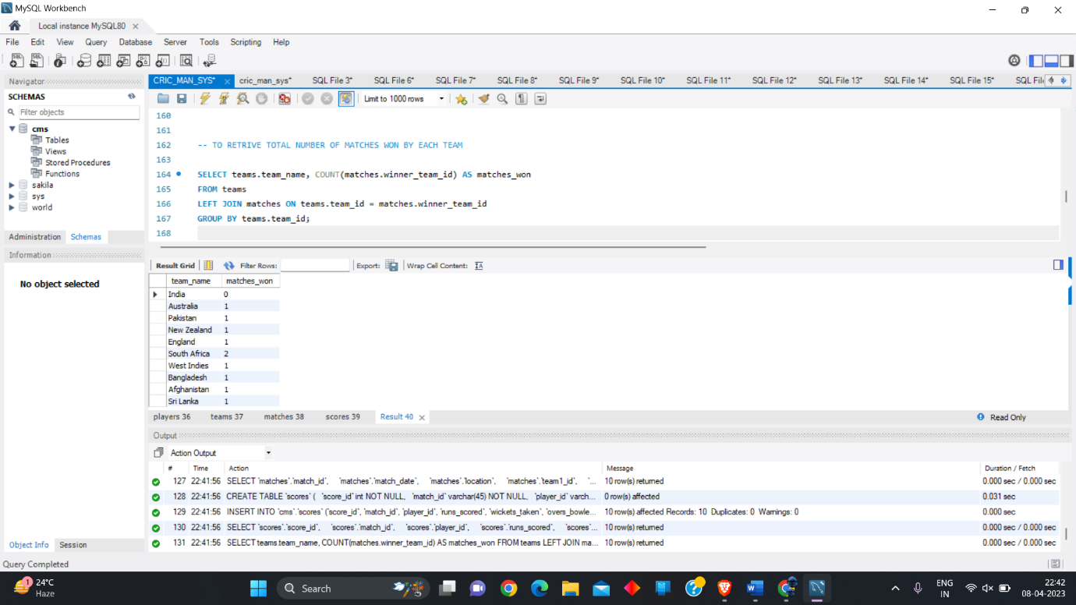

12.Retrieve the average age of players in a team.

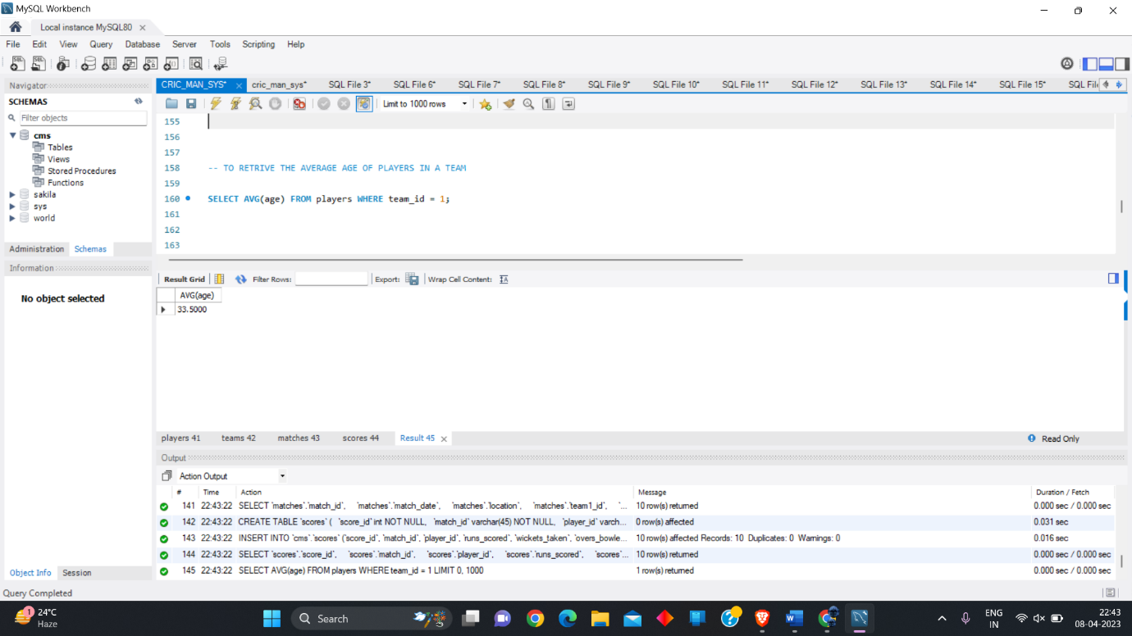

13.Retrieve the highest wickets_taken by a player in

a match.

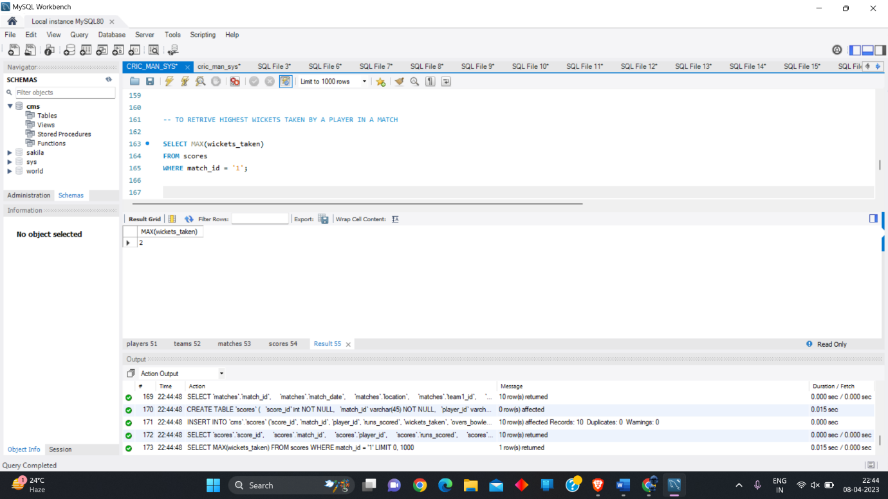

14.Retrieve the team with the most number of

runs_scored across all matches.

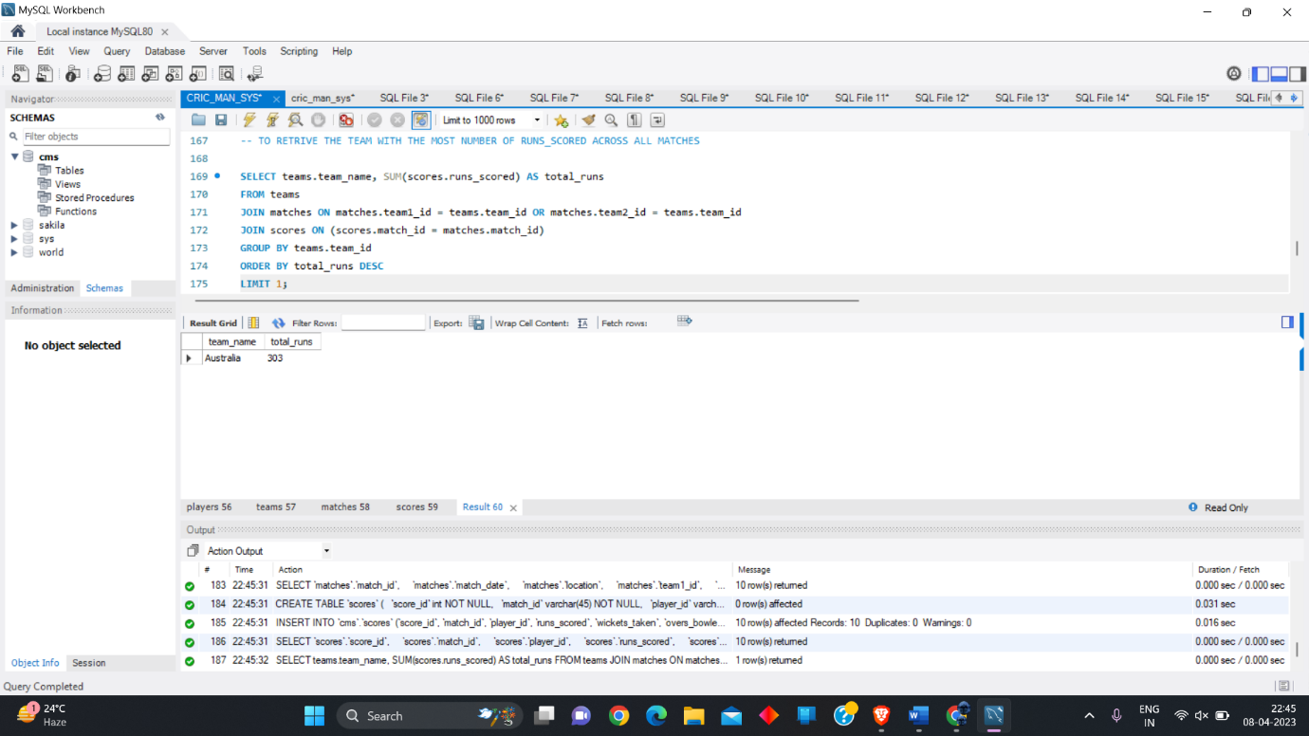

15.Retrieve the player_name and player_type for

all players in a specific team.

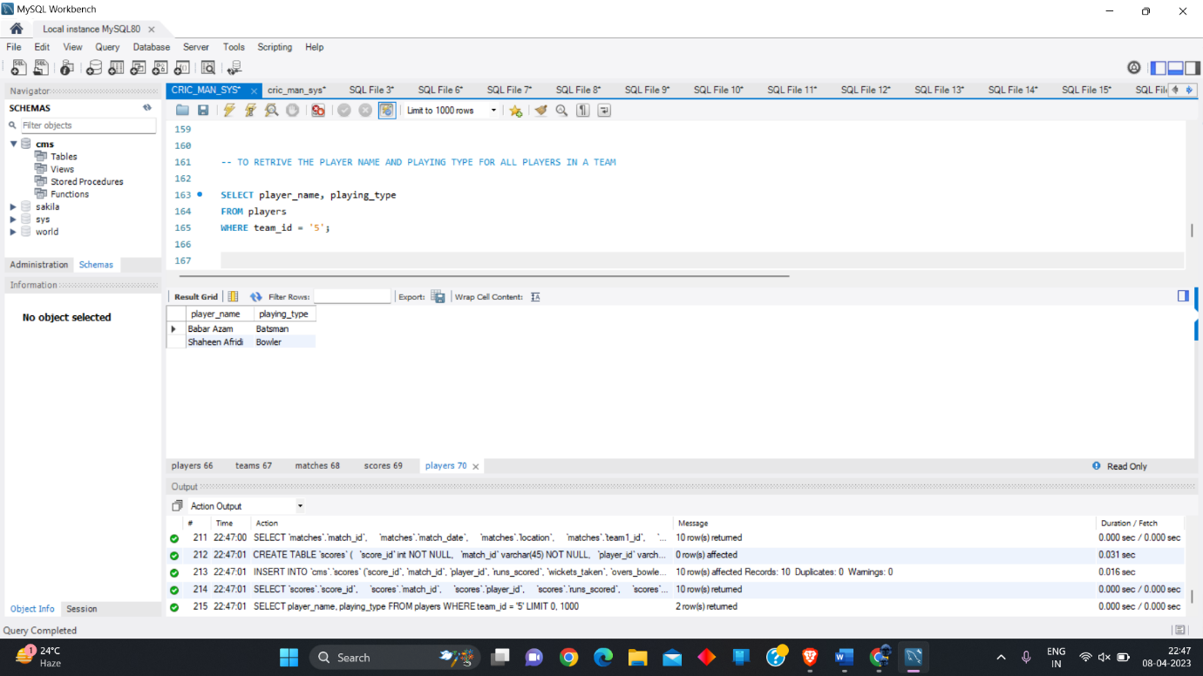

16.Retrieve the team_name and coach_name for all

matches won by a specific team.

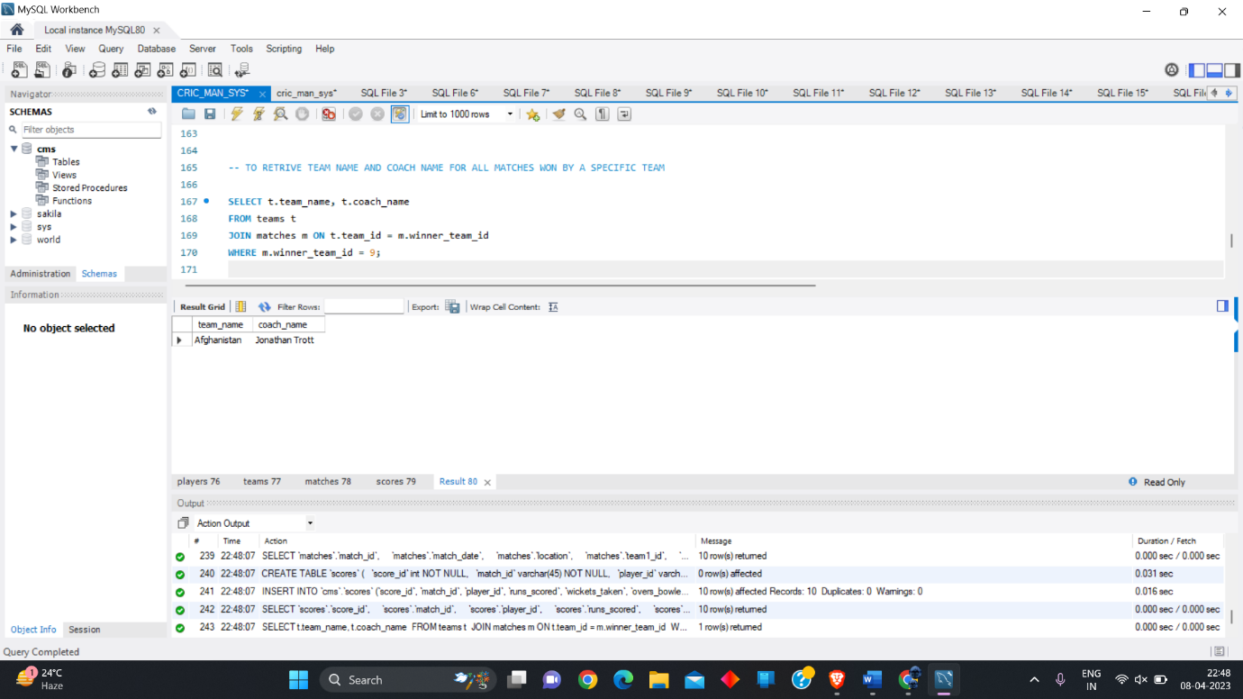

17.Retrieve the match_date, location, and

player_name for all matches played by a specific

player.

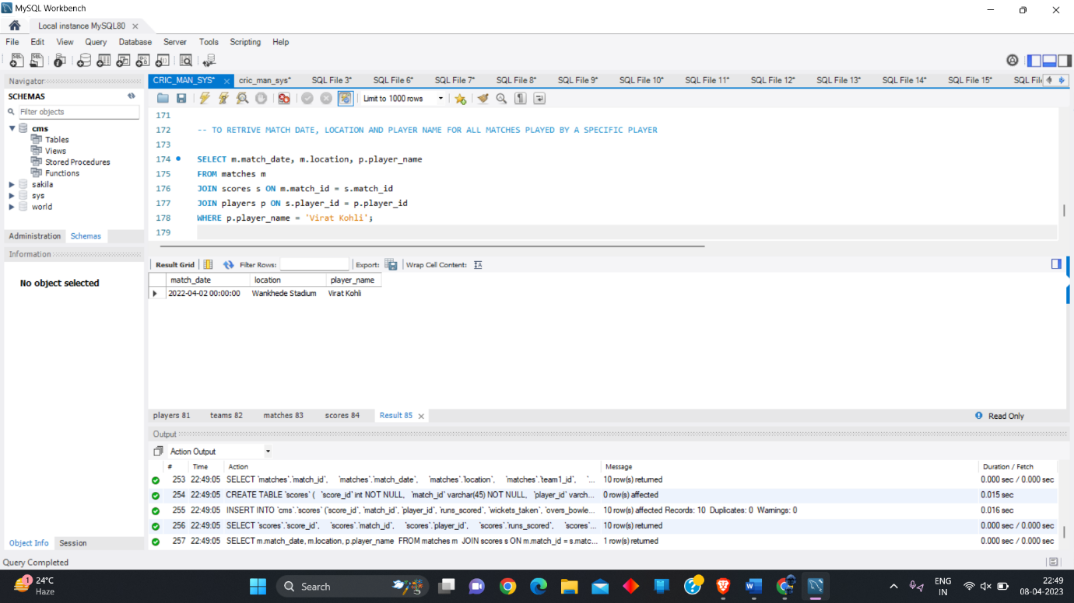

18.Retrieve the team_name, match_date, and

runs_scored for all matches where a specific

player scored more than 50 runs.

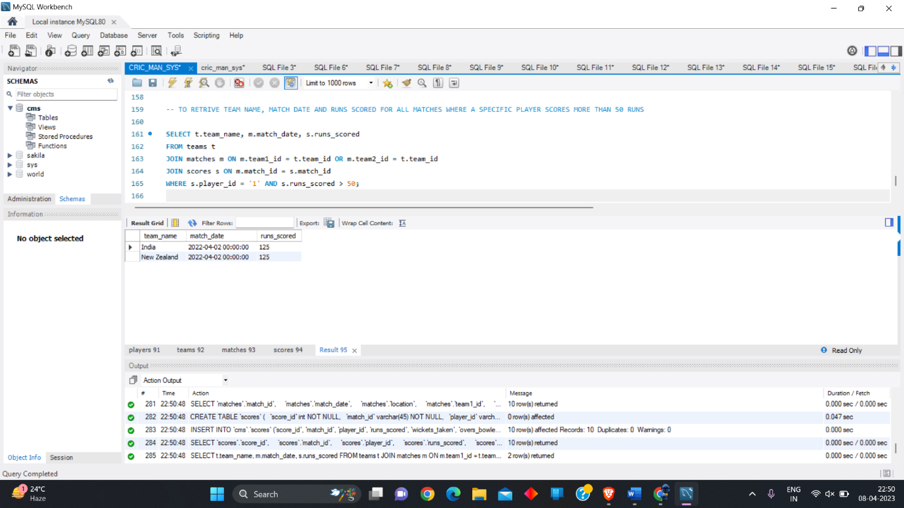

19.Retrieve the player_name, match_date, and

wickets_taken for all matches where a specific

player took more than 1 wickets.

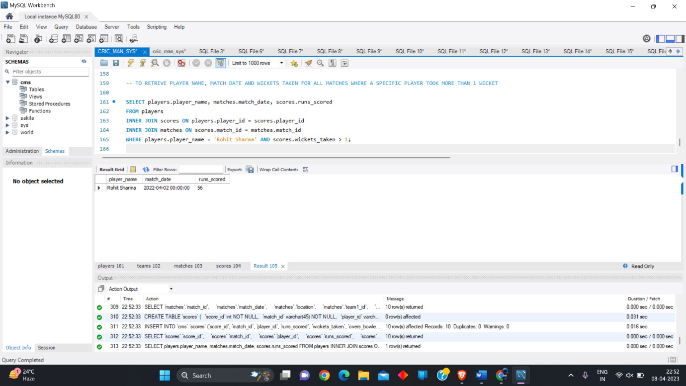

# VIDEO LINK

<https://drive.google.com/file/d/1rQsTXOuHK-1Ssb0-a4PRfein20XJvz7U/view?usp=share_link>